Mongolia, Interview with Old Woman Herder (Pensioner)

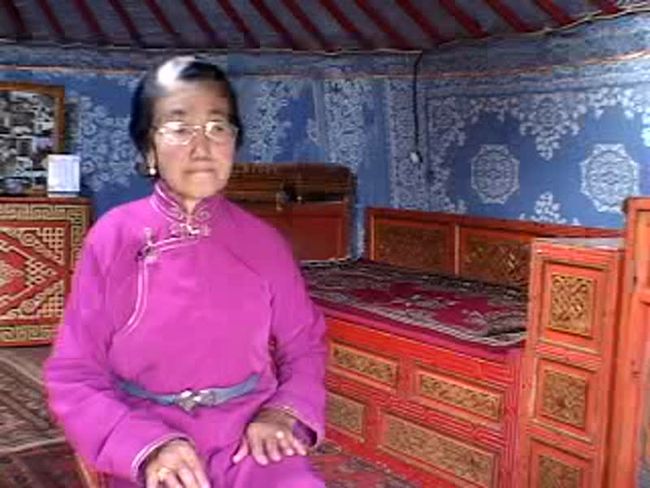

### identifier

00200108-0d64-476f-a956-ed8e9f5e985b

### creator

Penn Museum

### type

Moving Image

### coverage

Mongolia

Töv aimag

### description

(Grandparents of Tuya's friend). Inside nice Ger (Pensioners' ger).

[22:55] B Roll, Hand sewing, man in foreground, details.

[38:00] Getting into truck, (cute).

[38:50] Power window on truck.

[39:00] Exteriors: playing Badmitton w/ kid at pensioner ger compound.

[43:00] Silouette - cows coming home.

[50:00] Wide exterior shot.

[51:30] Wide exterior shot.

[57:00] Big Wide.

### publisher

University of Pennsylvania Museum of Archaeology and Anthropology Films

### source

<https://archive.org/details/UPMAA_films>

### rights

All rights are reserved by the University of Pennsylvania Museum of Archaeology and Anthropology (Penn Museum). Any use of the footage in productions is forbidden unless rights have been secured by contacting the Penn Museum Archives at 215-898-8304, or email photos@pennmuseum.org. This film and all of the films in the Penn Museum collection are copyrighted by the Penn Museum, and are not in the public domain.

### subject

### date

2009-01-08 12:17:53

### language

Mongolian

### original filename

V-450-06.mp4

### extent

98.8 MiB

1931.965299

### format

video/mp4

### modified

2009-01-08 03:17:52

### remote embed url

https://archive.org/embed/V-450-06

### public

FALSE