Noogii and Enkhee branding camels

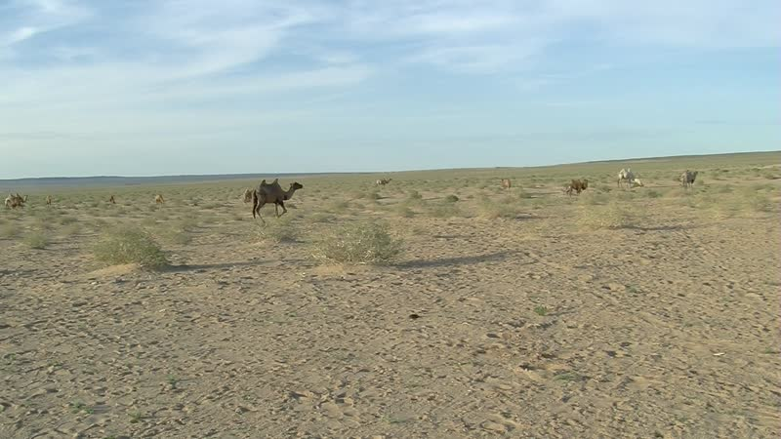

### identifier

01f710b7-40f1-4994-94be-16696789d9a4

### creator

Thrift, Eric

### type

Moving Image

### coverage

Mongolia

Dornogovi aimag

Sainshand sum

### description

The recordings in this series depict Noogii and Enkhee branding young camels at their summer camp, next to Khamar Monastery.

### publisher

### source

### rights

### subject

Pastoralism Videos

Branding Camels

Noogii-Enkhee

### date

2012-07-04

### language

### format

inode/directory

### modified

2018-03-02 09:37:44

### original filename

PastoralismVideos--2012-07-04--BrandingCamels--Noogii-Enkhee--Dornogovi-Sainshand.vclips

### table of contents

|  |  |  |
| --- | --- | --- |
| time | clip | description |
| 0:00:00 | 300G0023 01 | The two nephews carry a tub of dung over to where the camels are to be branded. Noogii comes over and tries lighting it. He takes out some of the dung and places it in a pile, then asks his nephew to take the rest of the dung away. Noogii sprinkles some gasoline on the dung pile, as the other nephew arrives carrying the branding iron. Noogii lights the fire as the two boys watch, then places in the branding iron in the fire to heat it up. He goes over to where the camels are standing as a group, and grabs one by a rope around its neck. Enkhee arrives and leads the camel to where the branding iron has been left. Running a rope around the camel's legs, as Enkhee holds the rope from the camel's neck, Noogii causes the camel to fall over. His nephew helps to hold the camel down as Noogii retrieves the branding iron and brands the camel. |
| 0:13:53 | 300G0023 02 | Noogii continues to brand the camels. He leads a camel and topples it, with the help of the two nephews, then brands the animal. He repeats this with a second camel, then rebuilds the fire and goes back to the camels. |
| 0:27:47 | 300G0023 03 | With some effort, Noogii catches and brands another camel, then goes off to lasso another one. |
| 0:41:40 | 300G0023 04 | Noogii and Enkhee continue branding the camels. Two visitors show up, and watch as Noogii brands two camels. |
| 0:55:34 | 300G0023 05 | Nootii, Enkhee, and their nephew continue roping camels. The nephew ropes one first, then Noogii ropes two. They bring the three camels over to be branded. |
| 1:09:28 | 300G0023 06 | The two visitors help hold down two camels as Noogii brands them. The older visitor rebuilds the fire. Enkhee ropes a camel but then loses it, and chases after it unsuccessfully. |
| 1:23:21 | 300G0023 07 | Noogii brands several more camels, then waits for the branding iron to heat up again. |
| 1:37:15 | 300G0023 08 | Noogii brands the last of the camels. |