Caroline Humphrey Mongolia Super8 film no. 21

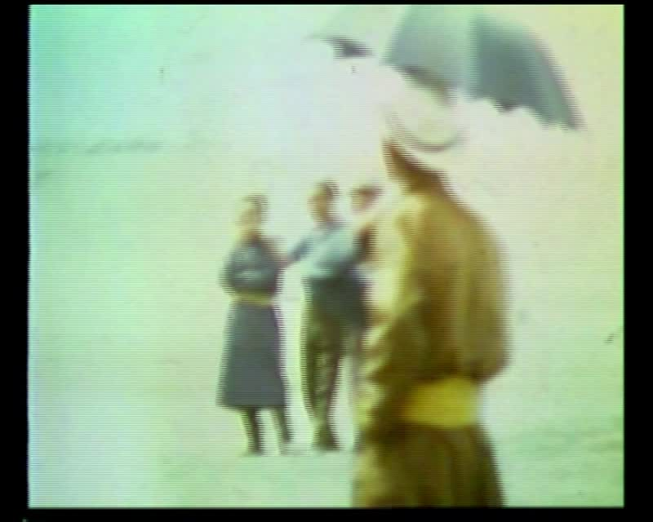

### identifier

02daede2-3431-470b-b6a7-57125bd1f891

### creator

Humphrey, Caroline

### type

Moving Image

### coverage

Mongolia

Ulaanbaatar

### description

Wrestling, horse race (crowd). Naadam Festival (Ulaanbaatar).

### publisher

MIASU

### source

Digitized from a VCR transfer tape held at the Mongolia and Inner Asia Studies Unit, University of Cambridge

### rights

Copyright Caroline Humphrey

### subject

Naadam

horse-racing

wrestling

### date

ca. 1970s

### language

None

### original filename

humphrey-super8-mongolia-21.mp4

### extent

800.1 MiB

225.963000

### format

video/mp4

### modified

2017-06-16 11:30:48

### alternate url

https://archive.org/embed/02daede2-3431-470b-b6a7-57125bd1f891