Caroline Humphrey - Buryatia photos - No. 01

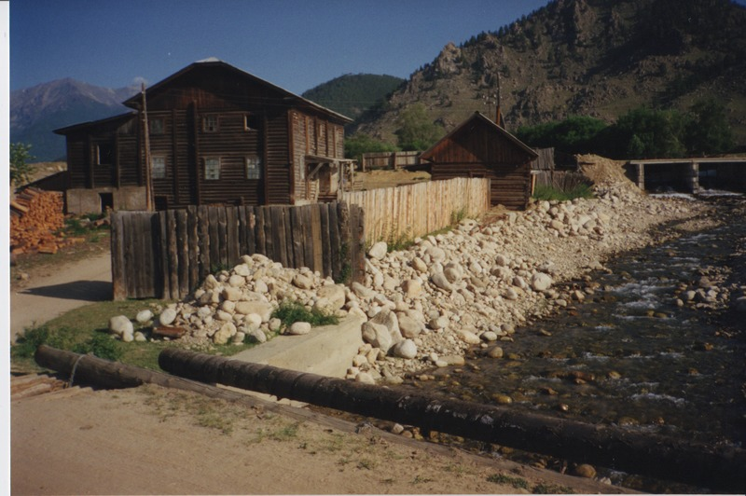

### identifier

041e2fa0-821e-47c4-8eee-15fa4c32bb6f

### creator

Humphrey, Caroline

### type

Image

### coverage

Ulung Collective

Buryatia

USSR

### description

Ulung flour mill

### publisher

### source

Scanned from a print held in the archives of the Mongolia and Inner Asia Studies Unit, University of Cambridge.

### rights

### subject

### date

1993-07-25

### language

### contributor

### original filename

Humphrey-Buryatia-photos-01.png

### relation

### extent

3.4MiB

1799x1196 px

### format

image/png