Vitafit factory tour image - 6hn8onds8ev7is3dq6klaqeps1 l

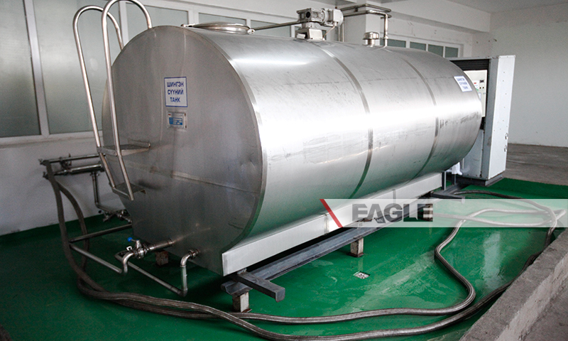

### identifier

04dd0868-afb2-446c-a895-ce3dae5a5a8b

### creator

### type

Image

### coverage

Mongolia

### description

Goyo yogurt factory tour image published by Eagle.mn.

### publisher

### source

### rights

### subject

Mongolia

dairy

nationalism

social media

### date

2014

### language

Vitafit factory tour image - Vitafit factory tour image - 6hn8onds8ev7is3dq6klaqeps1 l

### format

image/jpeg

### original filename

6hn8onds8ev7is3dq6klaqeps1_l.jpg

### extent

347.2 KiB

800x480 px

### modified

2014-03-24 18:28:58