Photograph of Handgate, Xinjiang by Tsui Yen Hu, 1993, No. 33

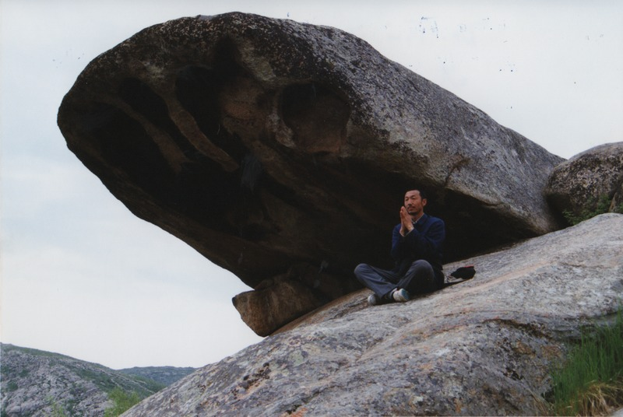

### identifier

0626f33e-4389-42de-ad77-9818ccea0108

### creator

Tsui Yen Hu

### type

Image

### coverage

Altai district

Handgate

PRC

Xinjiang

### description

Dr. Tsui meditating at five-Finger Spring, Handgate. This is an elevated rock, with five rocks spreading out below it. It is said to be very holy. It faces towards a group of three birch trees, which are also sacred. Behind the rock is a large oboo.

### publisher

### source

Scanned from colour print held in the archives of the University of Cambridge MacArthur Project "Environmental and Cultural Conservation in Inner Asia", Mongolia and Inner Asia Studies Unit.

### rights

### subject

medicine

### date

1993-05-27

### language

### format

image/png

### contributor

### original filename

TsuiYenHu-Handgate-1993-33.png

### relation

### extent

1777x1191 px

3.3 MiB