Batjargal's winter camp, Yeröö

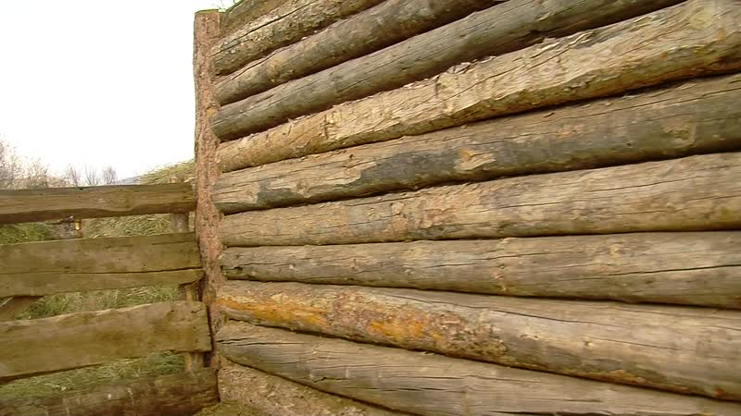

### identifier

0d5ffd33-7292-470d-93b6-20dc2640aa0b

### creator

Thrift, Eric

### type

Moving Image

### coverage

Mongolia

Selenge aimag

Yeröö sum

### description

In this video clip, Batjargal presents his winter camp. Batjargal and his wife Bayaraa are keeping a flock of Yeröö sheep belonging to their son Boldbaatar, who is living in town with his family now that his children are going to primary school and kindergarten. Boldbaatar and his wife have recently spent some time in the countryside helping out with the birthing of lambs. As they assert that it is extreme bad luck for an outsider to set eyes on newborn livestock, we have not made any recordings of the animals inside the shelter.

### publisher

### source

### rights

### subject

Pastoralism Videos

Winter Camp

Yeroo Sheep

Batjargal

### date

2012-03-29

### language

### remote embed url

https://archive.org/embed/0d5ffd33-7292-470d-93b6-20dc2640aa0b

### format

inode/directory

### modified

2018-03-01 17:01:16

### original filename

PastoralismVideos--2012-03-29--WinterCamp--YerooSheep--Batjargal--Selenge-Yeroo.vclips

### table of contents

|  |  |  |
| --- | --- | --- |
| time | clip | description |
| 0:00:00 | 244 0227 01 |  |