Inner Mongolia pasture fence

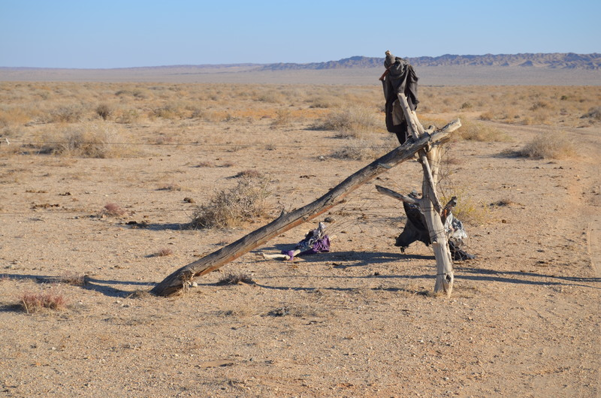

### identifier

0e238513-3e27-4b01-8003-7f8243480713

### creator

White, Thomas

### type

Image

### coverage

Alashan

Inner Mongolia

PRC

### description

Wire fencing to enclose household pasture.

### publisher

### source

Image submitted by the author.

### rights

Copyright Thomas White. All rights reserved. Please contact the author for information on re-use.

### subject

camels

### date

2013-11-02 08:53:20

### language

### format

image/jpeg

### contributor

### original filename

fence.JPG

### relation

### extent

3.9MiB

4928x3264 px