4016

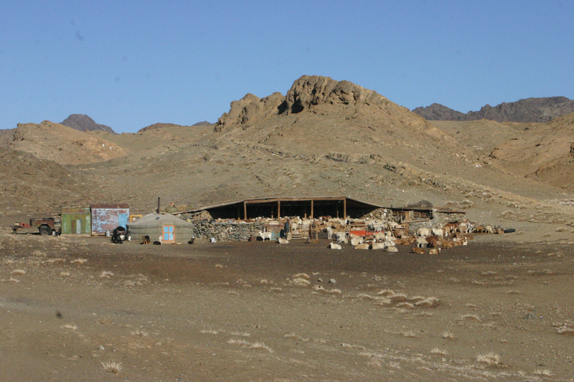

### identifier

0e46f295-d091-49dd-af51-3ae95b3ce8b9

### creator

Boldbaatar, Yu.

### type

Image

### coverage

Mongolia

### description

Livestock near a herder

### publisher

### source

https://ich.unesco.org/img/photo/src/4016.jpg

### rights

### subject

### date

2010

### language

### original filename

04016.jpg

### extent

4.1 MiB

3072x2048 px

### format

image/jpeg

### modified

2012-12-05 02:28:26