Map of NK Roerich’s Central Asian expeditions

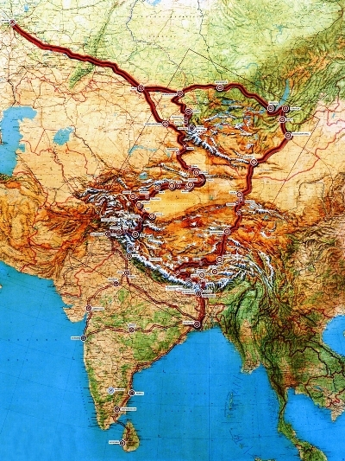

### identifier

0e8a6480-a368-41a9-8899-d4c113ff38de

### creator

Roerich Museum

### type

Image

### coverage

Mongolia

PRC

### description

Map showing the expedition routes of NK Roerich, from the Roerich Museum.

### publisher

### source

<http://www.museum.ru/alb/image.asp?73588>

### rights

Copyright museum.ru

### subject

expeditions

maps

### date

### language

Russian

### format

image/jpeg

### modified

2017-10-09 12:07:15

### original filename

Roerich_karta_ekspedition.jpg

### extent

312.6 KiB

400x533 px