Caroline Humphrey - Buryatia photos - No. 3-05

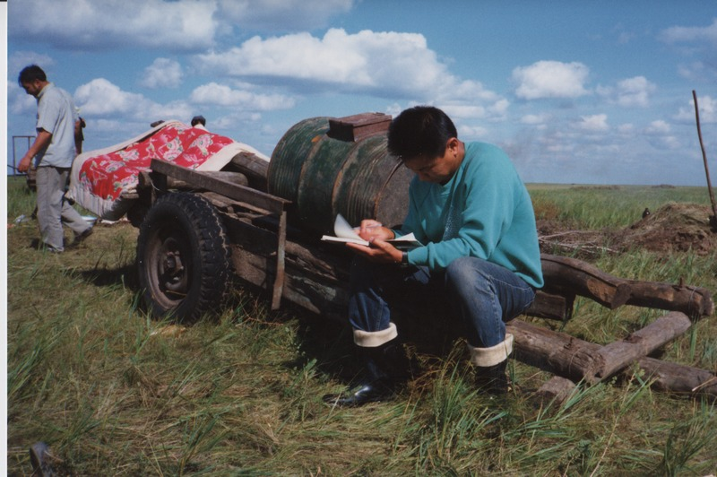

### identifier

0fadc11f-8a6b-43f2-a31d-4066d0c20b6c

### creator

Humphrey, Caroline

### type

Image

### coverage

Khargant

### description

Balzhan taking notes.

### publisher

### source

Scanned from a print held in the archives of the Mongolia and Inner Asia Studies Unit, University of Cambridge.

### rights

### subject

### date

1993

### language

### contributor

### original filename

Humphrey-Buryatia-photos-3-05.png

### relation

### extent

3.5MiB

1799x1196 px

### format

image/png