2282129. Pilgrimage to the Khosheutovsky Temple

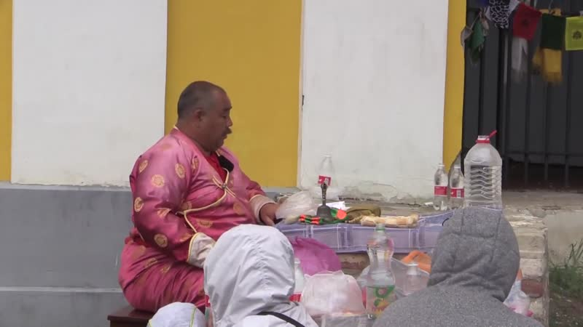

### identifier

0fc35be2-5492-4ec0-952b-6e917a98ddb8

### creator

Kalmyk Cultural Heritage Documentation Project

### type

Moving Image

### coverage

Kalmykia

Russia

### description

### publisher

University of Cambridge

### source

<http://www.kalmykheritage.socanth.cam.ac.uk>

### rights

Copyright Kalmyk Cultural Heritage Documentation Project. Licensed under a Creative Commons BY-NC-ND Unported license.

### subject

Buddhism

Kalmyks

### date

2016-07-16 17:31:35

### language

### extent

1.2 GiB

3190.600000

### format

video/mp4

### modified

2016-07-16 09:31:34

### original filename

2282156.mp4

### remote embed url

http://sms.cam.ac.uk/media/2282129/embed

### public

FALSE