Cover of the book *Mongolian Music, Dance, & Oral Narrative: Performing Diverse Identities*

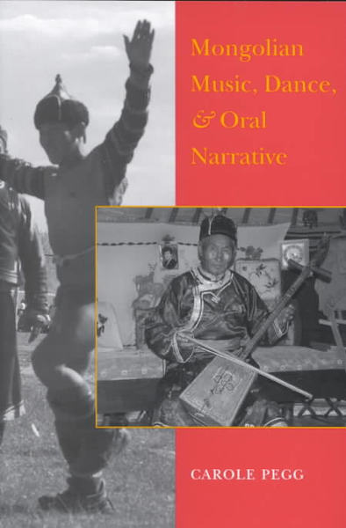

### identifier

0fc65e77-6c8e-4b5b-8539-5f1154cac9e0

### creator

Pegg, Carole

### type

Image

### coverage

Mongolia

### description

Book cover

### publisher

University of Washington Press

### source

### rights

Copyright UW Press

### subject

books

ethnomusicology

### date

2017-05-23 10:37:22

### language

English

### format

image/jpeg

### contributor

### original filename

music-dance-oral-narrative-book-cover.jpg

### relation

### extent

30.2KiB

449x684 px