Photograph from Govisumber, No. 25

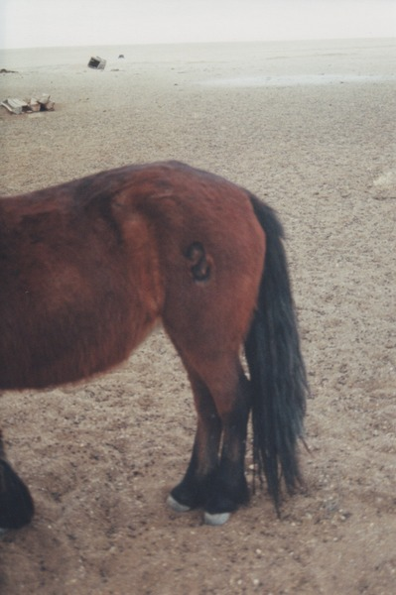

### identifier

111942e9-8197-45d6-b816-847b636bfe30

### creator

Sneath, David

### type

Image

### coverage

Govisumber aimag

Mongolia

### description

### publisher

### source

scanned from a photographic print held in the archives of the Mongolia and Inner Asia Studies Unit, University of Cambridge

### rights

### subject

branding foals

horse brand

pastoralism

### date

1995

### language

### format

image/png

### contributor

### original filename

sneath-govisumber_25.png

### relation

### extent

1182x1776 px

3.1MiB