Photographs of Dashbalbar sum, No. 39

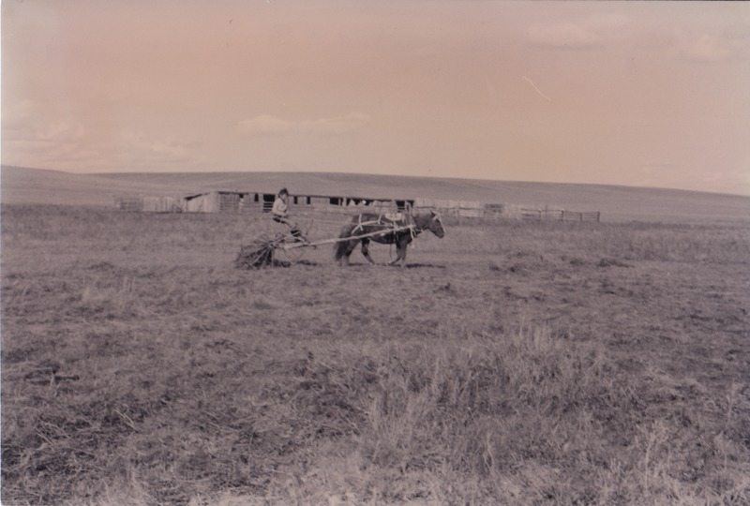

### identifier

11f12ad5-aecb-4089-ae4c-6f256d65f4d9

### creator

Batbuyan B.

### type

Image

### coverage

Dashbalbar sum

Dornod aimag

Mongolia

### description

HH 13 making hay.

### publisher

### source

Scanned from a photographic print held in the archives of the Mongolia and Inner Asia Studies Unit, University of Cambridge.

### rights

### subject

hay

### date

1993, summer

### language

### format

image/png

### contributor

### original filename

bair-batbuyan-photos-39.png

### relation

### extent

1757x1185 px

2.8 MiB