Photographs of Dashbalbar sum, No. 49

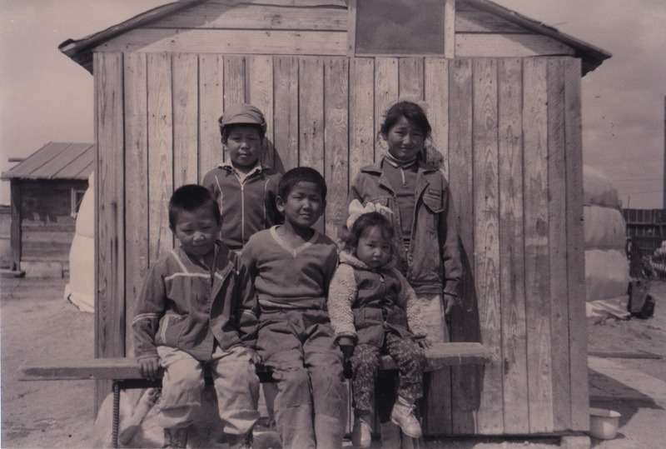

### identifier

1237cbc4-ce3f-42b5-977d-70226824a162

### creator

Batbuyan B.

### type

Image

### coverage

Dashbalbar sum

Dornod aimag

Mongolia

### description

Household No. 7, Baatar’s children.

### publisher

### source

Scanned from a photographic print held in the archives of the Mongolia and Inner Asia Studies Unit, University of Cambridge.

### rights

### subject

research participants

### date

ca. 2000

### language

### format

image/png

### contributor

### original filename

bair-batbuyan-photos-49.png

### relation

### extent

1755x1182 px

3.0 MiB