Feltmaking at Khandgait, Yeroo sum, Selenge aimag (part II)

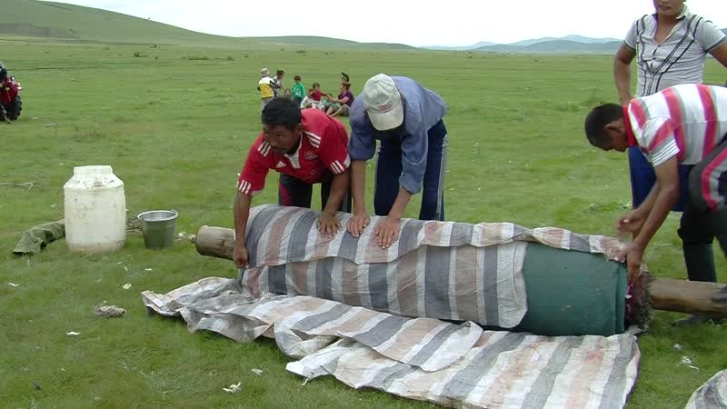

### identifier

12f6d2af-0017-41ba-b249-4aeac6ffee93

### creator

Thrift, Eric

### type

Moving Image

### coverage

Mongolia

Selenge aimag

Yeröö sum

### description

This series of videos documents feltmaking at Purevjav's place in Khandgait, Yeroo, over two days in late summer. Several families participated in the feltmaking, each bringing their own wool and sharing in the labour of beating and drawing the felt. I visited Purevjav in the company of my mother, along with Dolgorsuren and Gerlee from Tasag. The recordings in this second part of the series depict the laying out and rolling of the felt. Purevjav--who is in charge of the event--insists that the feltmakers produce felt in two different ways, drawing the roll behind a tractor and manually, for the benefit of the video recording. The host family also slaughters a sheep and a goat, preparing a feast for the feltmakers, as the feltmaking continues. Recordings at the end of this series depict rope-making and a brief visit to the neighbour Boldoo's home, where Boldoo shows off his race horses and a driven well constructed with development project funds.

### publisher

### source

### rights

### subject

Pastoralism Videos

Felt Making

Slaughtering Sheep Goat

Driven Well

Race Horses

Purevjav

### date

2012-08-13

### language

### format

inode/directory

### modified

2018-03-02 09:37:44

### original filename

PastoralismVideos--2012-08-13--FeltMaking--SlaughteringSheepGoat--DrivenWell--RaceHorses--Purevjav--Selenge-Yeroo.vclips

### table of contents

|  |  |  |
| --- | --- | --- |
| time | clip | description |
| 0:00:00 | 300G0095 01 | Purevjav and his son send the sheep off to pasture. Ochir slaughters a goat by decapitating it, bragging about the action. He cuts the forelegs off the goat and hangs the carcass from the side of his father's truck, then continues skinning the carcass. |
| 0:13:53 | 300G0095 02 | Ochir finishes skinning the goat. He then removes the offal. As he butchers the carcass. Purevjav takes the stomach and leaves it in the field some distance away. Ochir's sister separates the intestines. Ochir unties a sheep whose rump was eaten overnight by a predator, and which he had tied to the truck. He slaughters the sheep. |
| 0:27:47 | 300G0095 03 | Gerlee and Purevjav's duaghters clean the intestines of the goat and sheep, as Ochir hangs and butchers the sheep carcass. Meanwhile others start laying out more wool on a tarpauling for beating. |
| 0:41:40 | 300G0095 04 | Butchering the sheep and cleaning the intestines. People gathered around the outdoor stove; Gerlee washes the goat stomach. |
| 0:55:34 | 300G0095 05 | Gathered around the outdoor stove. |
| 0:57:29 | 300G0096 01 | The feltmakers drag a tarpaulin with beaten wool away from the yurt, then lay out two more tarpaulins for setting the wool in place to make felt. Everyone begins placing the beaten wool on the tarpaulin. Purevjav's youngest daughter stitches together two pieces of canvas to make a continuous tarpaulin large enough for a roll of felt. |
| 1:11:23 | 300G0096 02 | Laying out wool. Indoors, Gerlee heats water to be used in wetting the wool. Purevjav's youngest daughter continues stitching the canvas. The son of the family whose felt is being made places a mark indicating the year (2012), using black wool, in the corner of the felt. |
| 1:25:17 | 300G0096 03 | Purevjav's daughter finishes stitching the canvas. The feltmakers sprinkle warm water over the laid-out wool. The men fold the edges of the tarpaulin over the top of the wool, then roll up the wet felt around a wooden shaft, covering the roll with a canvas tarpaulin, and bind the roll tightly. Azaa and her husband Byambaa carry the roll a short distance away. |
| 1:39:11 | 300G0096 04 | Purevjav and the others begin rolling the felt manually. Two people stand on each side of the roll of felt, holding one end of a rope spun around the roll. The feltmakers on either side alternate in pulling on their ends of the ropes, causing the ropes to unwind and send the roll towards their counterparts. As this goes on, others continue beating wool. Boldoo opens up the end of the roll of felt; it is not done yet, so he tightens the binding and they continue rolling. |
| 1:53:05 | 300G0096 05 | Rolling felt manually. Behind the yurt, several women have nearly finished laying out the wool for a second felt. |
| 1:57:20 | 300G0097 01 | Laying out wool. Pulling a roll of felt manually. |
| 2:11:13 | 300G0097 02 | The feltmakers sprinkle warm water over the laid out wool. Once this is complete they roll up the wool and bind the roll. |
| 2:25:07 | 300G0097 03 | The feltmakers tie the two protruding ends of the shaft at the centre of the roll of felt behind a tractor. The tractor drives off. Bataa and Purevjav untie the first roll of felt. They tug at the edges to straighten it out, then tightly roll the felt directly around the wooden shaft. They roll the felt back and forth several times over the canvas tarpaulin, leaning into the felt to compress the fibres. The tractor comes back towards the yurt. |
| 2:39:01 | 300G0097 04 | The tractor driven by Ochir arrives outside the yurt. Purevjav's daughter pours water over the ends of the wooden shaft to cool them off. Ochir drives off. |
| 2:52:54 | 300G0097 05 | Ochir drives the tractor back to the yurt. The feltmakers unhitch the roll of felt, remove the bindings, and open up the roll. |
| 2:58:05 | 300G0098 01 | The feltmakers place a tarpaulin on top of the laid-out felt that has just been pulled behind the tractor. On top of this they lay out the first felts, then cover these with a cotton cloth covering for the interior of the yurt (tsavag); the new felts will be rolled up around the earlier ones. They begin laying out wool for another felt. |
| 3:11:59 | 300G0098 02 | Purevjav and Gerlee separate mixed-coloured wool. The feltmakers finish laying out wool for the next felt, and sprinkle water over top of it. They cover the wool with cloths. |
| 3:25:53 | 300G0098 03 | The feltmakers roll up the felts, then tie up the bundle. They hitch the roll of felt to the back of the tractor, which then drives off. |
| 3:32:55 | 300G0099 01 | Gerlee heats water in a pot on the outdoor stove. |
| 3:34:35 | 300G0100 01 | Laying out wool. Beating Purevjav's mixed-coloured wool. The tractor drives closer; the men with the tractor fix the bindings on the roll of felt. |
| 3:48:29 | 300G0100 02 | The tractor drives off. The feltmakers continue beating wool. |
| 3:52:44 | 300G0101 01 | Laying out dark wool. |
| 3:55:49 | 300G0102 01 | Sprinkling water over the wool. The tractor returns. The feltmakers roll up the next felt. The roll brought by the tractor is unrolled. The feltmakers remove the top felt and carry off the very first felt, which was at the bottom of the roll. They tug at the edges of the felt to straighten it out. The next roll of felt is prepared. |
| 4:09:42 | 300G0102 02 | The feltmakers cover the laid-out wool with a sheet of cotton, and begin laying out more wool on top of it. Meanwhile others take turns rolling felt by hand. |
| 4:23:35 | 300G0102 03 | The next felt is laid out; the feltmakers sprinkle water over it. The felt that was being rolled manually is opened up. The new felt is rolled up with the older ones and bound. |
| 4:37:29 | 300G0102 04 | The men hitch the new roll of felt to the tractor, and Byambaa gets ready to drive off. But the end of the wooden shaft breaks off. The men find a saw and hatchet, and cut a new tip for the shaft. Once this is done they hitch the roll to the tractor, and the tractor drives off. |
| 4:51:23 | 300G0102 05 | Pulling the roll of felt behind the tractor. |
| 5:05:17 | 300G0102 06 | Pulling the roll of felt behind the tractor. |
| 5:09:31 | 300G0103 01 | Purevjav is making rope using a bale of plastic twine. He runs the twine through an exposed section of the yurt wall, next to the door, and twists the strands from outside the yurt with two assistants as Boldoo pulls on the rope from indoors. Boldoo binds the end of the rope. |
| 5:23:24 | 300G0103 02 | Boldoo finishes binding the end of the rope, then melts the end to prevent fraying. |
| 5:28:48 | 300G0104 01 | Purevjav begins making a second rope. He twists the twine into strands. |
| 5:42:42 | 300G0104 02 | Purevjav continues making rope. Various people take turns helping with the twisting. |
| 5:51:15 | 300G0104 03 | Purevjav continues making rope. Various people take turns helping with the twisting. Purevjav's daughters prepare meat and vegetables for khorkhog. |
| 6:05:08 | 300G0104 04 | The ropemaking continues. Meanwhile, behind the yurt, the felt-makers take a break from laying out wool. Boldoo removes the twisted rope from the yurt. Bataa and others put the meat and vegetables for khorkhog along with stones into a pot on top of the outdoor stove. Boldoo binds the end of the rope. The feltmakers trim the edges of a new felt that has just been pulled by the tractor. They beat the felt with their hands to even it out. |
| 6:19:02 | 300G0104 05 | The feltmakers finish straightening out the new felt and lay it out as the new “mother felt”. They sprinkle warm water over the felt and over the shaft, then roll it up and attach the roll to the tractor, as the other red tractor arrives. The tractor pulling the new roll of felt drives off. |
| 6:31:38 | 300G0105 01 | Boldoo demonstrates a driven well that was set up with project funding. Boldoo is responsible for maintaining the well and the diesel pump on behalf of the several households in the “herder group” who share this well. |
| 6:33:38 | 300G0106 01 | Boldoo shows off his horses. He attaches a rope bridle and helps his daughter onto the back of an untrained horse. |
| 6:44:46 | 300G0107 01 | Inside his yurt, Boldoo shows off a leather bridle. |
| 6:45:15 | 300G0108 01 | Boldoo's children show off the horses, riding at the entrance of the yurt. |
| 6:50:05 | 300G0109 01 | A Bayad family home, near Purevjav's place |