Photographs of Dashbalbar sum, No. 41

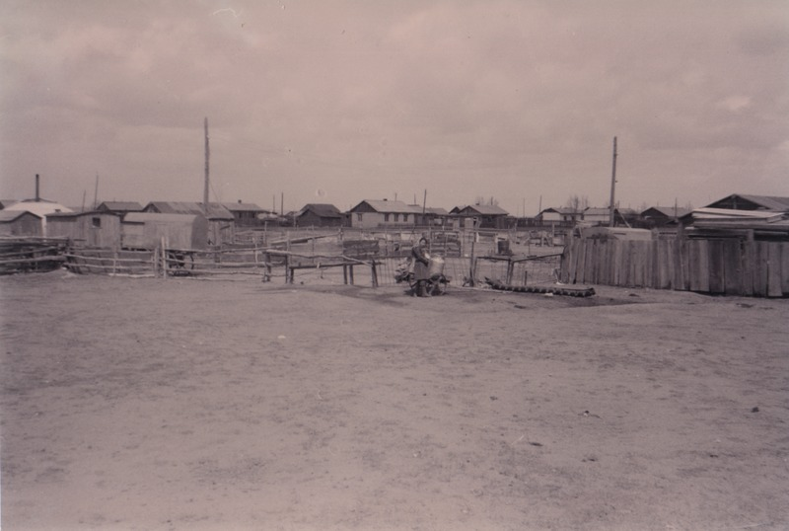

### identifier

13bf8325-c4cf-4961-acfe-56268ddecb13

### creator

Batbuyan B.

### type

Image

### coverage

Dashbalbar sum

Dornod aimag

Mongolia

### description

One of the many wells in Dashbalbar sum centre.

### publisher

### source

Scanned from a photographic print held in the archives of the Mongolia and Inner Asia Studies Unit, University of Cambridge.

### rights

### subject

settlements

water use

wells

### date

ca. 1993

### language

### format

image/png

### contributor

### original filename

bair-batbuyan-photos-41.png

### relation

### extent

1756x1181 px

2.7 MiB