Photographs from Barguzin, No. 09

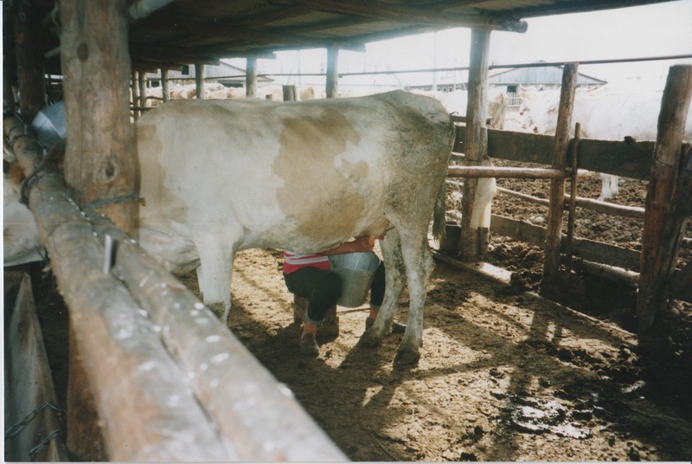

### identifier

13d9284b-351f-4b75-beda-c74789eaca3a

### creator

Gomboev, Bair

### type

Image

### coverage

Barguzin

Burtyatia

Russian Federation

### description

Summer camp, milking, Argada selsoviet.

### date

1993-07

### language

### format

image/png

### modified

2017-05-25 02:04:08

### original filename

bair-batbuyan-photos-09.png

### source

Scanned from a photographic print held in the archives of the Mongolia and Inner Asia Studies Unit, University of Cambridge

### extent

3.3 MiB

1777x1191 px

### subject

milking

pastoral camps