Tsagaan's cattle, Yeröö sum

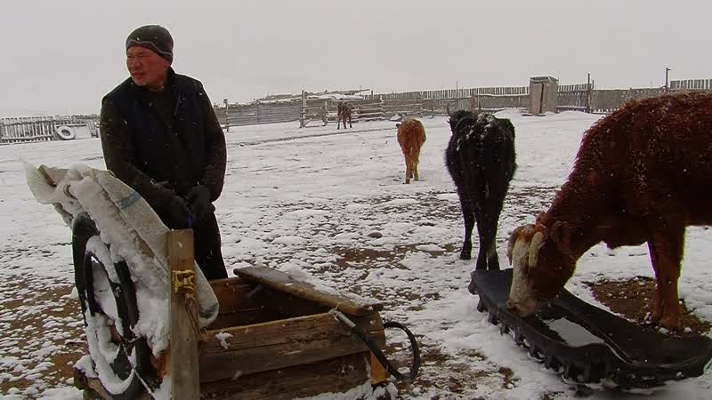

### identifier

140fae6f-1b04-414a-a75c-2b93c4b02287

### creator

Thrift, Eric

### type

Moving Image

### coverage

Mongolia

Selenge aimag

Yeröö sum

### description

Tsagaan, a retiree who lives in Yeröö sum centre, shows off the cattle he keeps in his yard. The cows are milked once a day, in the morning. Tsagaan keeps a bull that was provided by the local government to be shared among several households in town.

### publisher

### source

### rights

### subject

Pastoralism Videos

Milking Cattle

Tsagaan

### date

2012-04-23

### language

### remote embed url

https://archive.org/embed/140fae6f-1b04-414a-a75c-2b93c4b02287

### format

inode/directory

### modified

2018-03-02 09:37:44

### original filename

PastoralismVideos--2012-04-23--MilkingCattle--Tsagaan--Selenge-Yeroo.vclips

### table of contents

|  |  |  |
| --- | --- | --- |
| time | clip | description |
| 0:00:00 | 244 0297 01 |  |
| 0:04:57 | 244 0298 01 |  |
| 0:08:05 | 244 0299 01 |  |