Caroline Humphrey - Buryatia photos - No. 2-21

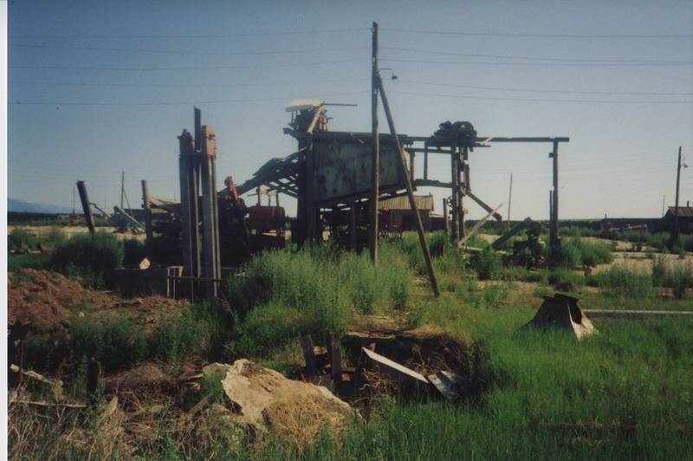

### identifier

145e98e6-b61a-4485-af37-c122b72c7e10

### creator

Humphrey, Caroline

### type

Image

### coverage

Bayangol

Khilgana

Karl Marx Collective

Buryatia

USSR

### description

Farm machinery.

### publisher

### source

Scanned from a print held in the archives of the Mongolia and Inner Asia Studies Unit, University of Cambridge.

### rights

### subject

### date

1993

### language

### contributor

### original filename

Humphrey-Buryatia-photos-2-21.png

### relation

### extent

3.3MiB

1799x1196 px

### format

image/png