La notion de « technique du corps » appliquée à l’étude des Mongols [The concept of "techniques of the body" applied to the study of the Mongols]

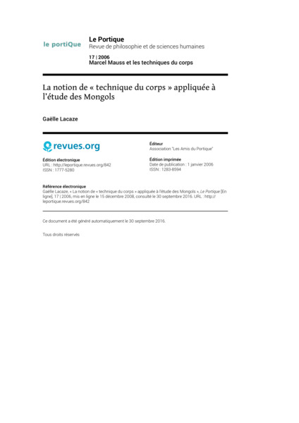

### identifier

14be5e0a-45fd-49b7-9fa5-3dac2f12a455

### creator

Lacaze, Gaëlle

### type

Text

### coverage

Mongolia

### description

The application of Marcel Mauss’s notion of “techniques of the body” to the study of the peoples of Mongolia shows how this notion must be adapted to suit each society. This article reveals Mauss’s brilliant intuitions which already suggested the necessity of these adaptations. The techniques of the body are essential instruments in the analysis of a group’s corporal language. Furthermore, they shed light on concepts concerning the individual and their position in the social and natural worlds. In this way, they participate in clarifying the Mongolian notion of humanity, as well as in revealing the ways in which nomadic peoples perceive the environment.

### publisher

Association "Les Amis du Portique"

### source

Gaëlle Lacaze, « La notion de « technique du corps » appliquée à l’étude des Mongols », Le Portique [En ligne], 17, 2006

<http://leportique.revues.org/842>

### rights

Copyright. All rights reserved.

### subject

Techniques of the body

Marcel Mauss

### date

2008

### language

French

### original filename

leportique-842.pdf

### extent

230.7 KiB

### format

application/pdf

### modified

2018-01-09 21:47:41