Photograph from Govisumber, No. 29

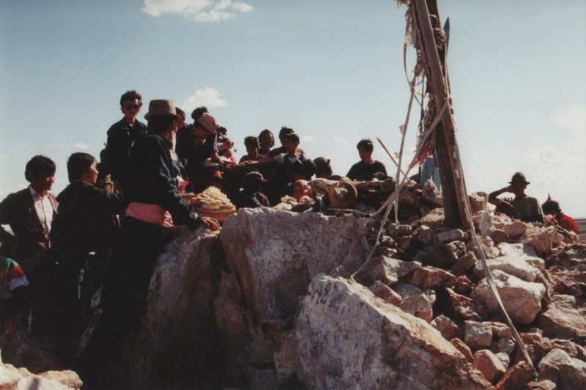

### identifier

14e2e23e-2bd0-468a-a7c7-90806e98b2c0

### creator

Sneath, David

### type

Image

### coverage

Govisumber aimag

Mongolia

### description

### publisher

### source

scanned from a photographic print held in the archives of the Mongolia and Inner Asia Studies Unit, University of Cambridge

### rights

### subject

ovoo

### date

1995

### language

### format

image/png

### contributor

### original filename

sneath-govisumber_29.png

### relation

### extent

1776x1182 px

3.2MiB