Milking cattle and collecting dung at Sainsanaa's place in Yeröö

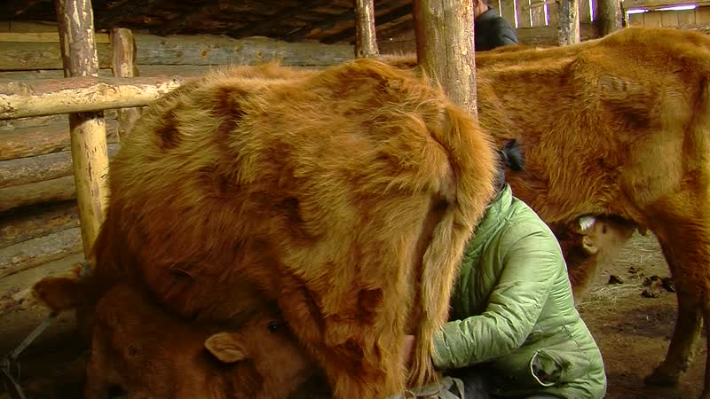

### identifier

1511340e-3855-4b08-a950-951ae01cb715

### creator

Thrift, Eric

### type

Moving Image

### coverage

Mongolia

Selenge aimag

Yeröö sum

### description

This series of audiovisual recordings documents Sainsanaa and his wife milking cattle, sending cows off to pasture, and gathering dung. This young couple has received some cows from the sum administration as part of a program to support young herders by supplying them with livestock of improved breeds.

### publisher

### source

### rights

### subject

Pastoralism Videos

Milking Cattle

Collecting Dung

Sainsanaa

### date

2012-04-19

### language

### format

inode/directory

### modified

2018-03-01 15:47:40

### original filename

PastoralismVideos--2012-04-19--MilkingCattle--CollectingDung--Sainsanaa--Selenge-Yeroo.vclips

### table of contents

|  |  |  |
| --- | --- | --- |
| time | clip | description |
| 0:00:00 | 244 0281 01 |  |
| 0:13:53 | 244 0281 02 |  |
| 0:27:47 | 244 0281 03 |  |
| 0:41:41 | 244 0281 04 |  |
| 0:43:08 | 244 0282 01 |  |
| 0:44:50 | 244 0283 01 |  |
| 0:49:13 | 244 0284 01 |  |
| 1:03:07 | 244 0284 02 |  |