L’orientation dans les techniques du corps chez les Mongols [Orientation refering to the techniques of the body]

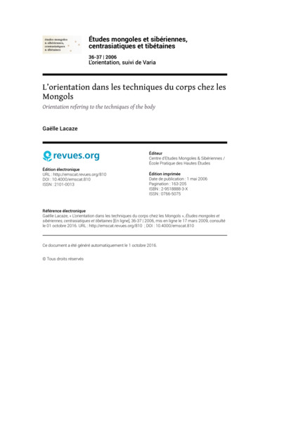

### identifier

156ee89f-00e4-403e-97ea-1b6ae466661c

### creator

Lacaze, Gaëlle

### type

Text

### coverage

Mongolia

Altai

Inner Mongolia

### description

The Mongol yurt forms a circular area with the fireplace in the centre. Without wall, it opens on the outside through a door and a round skylight that a chimney goes across. For all, the yurt is an area with implicit demarcation lines that divide its internal space in several places distinctively identified. On the contrary, while analysing ways of moving and acting under the yurt, this article sheds light on an area where each category of person, according to their age, gender and social status, has a specific place. Moreover, outside the yurt, in the wide world, techniques of the body are distinct one from the other according to each area and to the passage through some of the limits dividing them, either symbolic or real ones. Indeed, arrangement of the yurt, its position on the camp and likewise the perceptions of the landscape for a part refer to the body. As a result, for the Mongols, the perceptions of the environmental world seem to be dynamic and based on the notion of movement.

### publisher

Centre d'Etudes Mongoles & Sibériennes / École Pratique des Hautes Études

### source

<http://journals.openedition.org/emscat/810>

Gaëlle Lacaze, « L’orientation dans les techniques du corps chez les Mongols », Études mongoles et sibériennes, centrasiatiques et tibétaines [En ligne], 36-37, 2006

### rights

Copyright. All rights reserved.

### subject

techniques of the body

space

movement

### date

2006

### language

French

### original filename

techniques-du-corps.pdf

### extent

314.4 KiB

### format

application/pdf

### modified

2018-01-09 21:43:45