Owen Lattimore interviewed by Caroline Humphrey, 21st May 1983 – Part 2

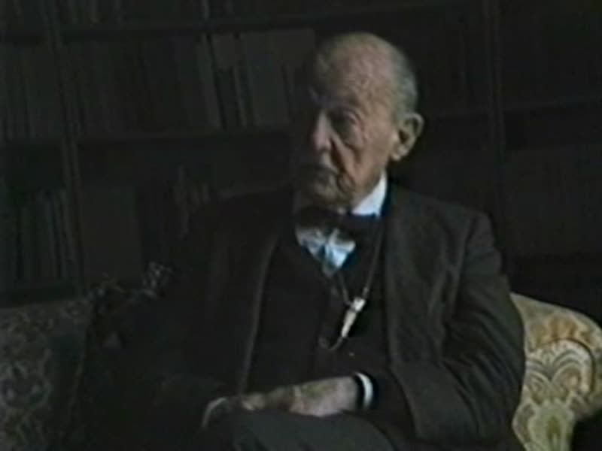

### identifier

15cff06d-ce32-481f-a55d-ff6e3a6a5322

### creator

Lattimore, Owen

### type

Moving Image

### coverage

Mongolia

China

### description

Owen Lattimore discusses Kazakhs; Mongolian education; his travelling companion Arash; Mongolian language and egalitarianism; Ulaankhuu and the Inner Mongolian nationalist movement; the Dilav Khutagt; the historian Ch. Dalai.

### publisher

### source

### rights

### subject

Kazakhs in Mongolia

social stratification

Ulaankhuu

Dilav Khutagt

nationalism

### date

1983

### language

English

### contributor

Humphrey, Caroline

### original filename

lattimore2.mp4

### relation

### extent

261.5 MiB

3066.240000

### format

video/mp4

### modified

2017-05-25 03:39:30

### remote embed url

### public