Daily operations at Delger Dairy, Sainshand

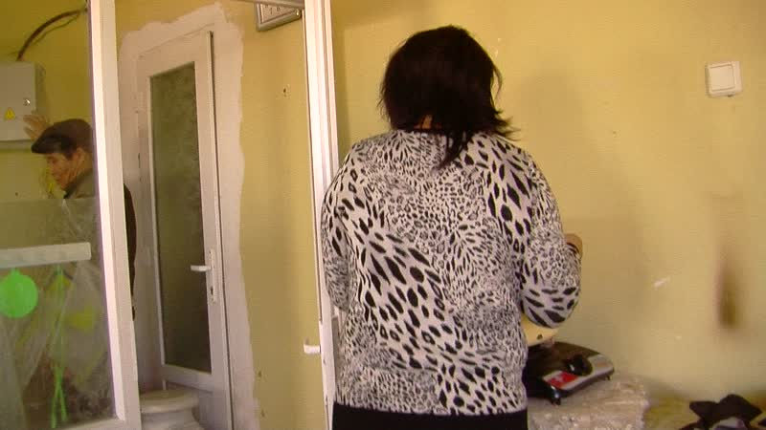

### identifier

16399c1a-8f14-49fb-9455-7cda2aa95945

### creator

Thrift, Eric

### type

Moving Image

### coverage

Mongolia

Dornogovi aimag

Sainshand sum

### description

This series of audiovisual recordings depicts the milk processing activities as Delger Dairy Co-op in Sainshand. The owners of the dairy, Delgersaikhan, a former state farm technician, and his wife Altantsetseg, a schoolteacher (who arrives later in the day), demonstrate their equipment and processes. Much of the day is spent packaging yoghurt in 200 ml single-serving cups cups for distribution to the local elementary school, through the publicly-funded lunch program. The owners and staff also work at separating and packaging sour cream, making a new batch of yoghurt, and producing aaruul. The cooperative also operates a farm to the south of Sainshand, with 13 dairy cows and a small number of sheep and goats, and a rented counter space in an indoor market in Sainshand. The cooperative employs two herders (husband and wife, who are relatives, as a milkmaid and herder), a seller, and two dairy technicians.

### publisher

### source

### rights

### subject

Pastoralism Videos

Delger Dairy

Pasteurizing Milk

Making Yoghurt

Separating Milk

### date

2012-03-09

### language

### format

inode/directory

### modified

2018-01-17 20:15:05

### original filename

PastoralismVideos--2012-03-09--DelgerDairy--PasteurizingMilk--MakingYoghurt--SeparatingMilk--Dornogovi-Sainshand.vclips

### table of contents

|  |  |  |
| --- | --- | --- |
| time | clip | description |
| 0:00:00 | 244 0167 01 |  |
| 0:00:08 | 244 0168 01 |  |
| 0:00:51 | 244 0169 01 |  |
| 0:14:45 | 244 0169 02 |  |
| 0:28:39 | 244 0169 03 |  |
| 0:42:33 | 244 0169 04 |  |
| 0:56:27 | 244 0169 05 |  |
| 0:58:24 | 244 0170 01 |  |
| 1:12:18 | 244 0170 02 |  |
| 1:26:13 | 244 0170 03 |  |
| 1:40:07 | 244 0170 04 |  |
| 1:45:14 | 244 0171 01 |  |
| 1:59:08 | 244 0171 02 |  |
| 2:00:03 | 244 0171 03 |  |