Moving camp - Nomin and Oyunaa on otor

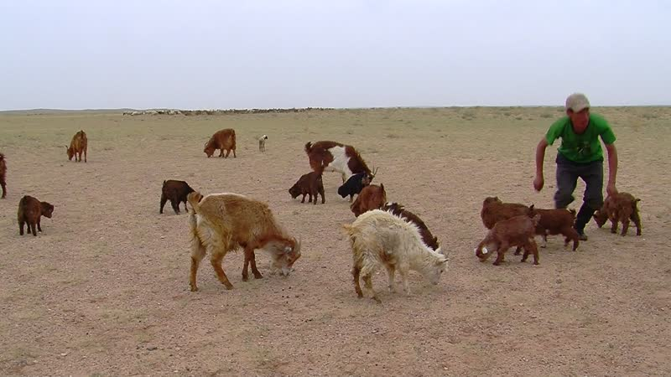

### identifier

167db836-fffc-4823-ab9c-625d7a024c91

### creator

Thrift, Eric

### type

Moving Image

### coverage

Mongolia

### description

This series of audiovisual recordings depicts an otor move by Nomin and Oyunaa. The family is moving approximately 50 km away from their regular home near Khamar Monastery, into Erdene sum, due to poor rainfall so far this spring. After several days of prevarication about where (or indeed whether) to move, Nomin and Oyunaa have decided to follow Dorjsüren, Batbayar, and other families who have moved to the target site, which is currently well vegetated. We show up in our Pajero along with Oyunaa's parents, while Eldev Lama arrives in his UAZ-369 Russian jeep, already loaded with his small yurt (otryn ger) that had been in storage at the Monastery. The seats of the jeep have been removed in order to be able to transport the small and weak livestock, who would be unable to make such a long journey. Everyone helps to load up the family's belongings, leaving behind the large winter yurt. Idermönkh stays behind to watch the livestock, and Oyunaa watches the children, as everyone else heads to the new camp site. Eldev and Nomin set up the small yurt, while Dolgor and Nar-Od pick wild onions.

### publisher

### source

### rights

### subject

Pastoralism Videos

Otor

Harvesting Wild Onions

Nomin-Oyunaa

Dornogovi-Sainshand Erdene

### date

2012-05-10

### language

### format

inode/directory

### modified

2018-01-18 09:34:52

### original filename

PastoralismVideos--2012-05-10--Otor--HarvestingWildOnions--Nomin-Oyunaa--Dornogovi-SainshandErdene.vclips

### table of contents

|  |  |  |
| --- | --- | --- |
| time | clip | description |
| 0:00:00 | 244 0324 01 |  |
| 0:00:55 | 244 0325 01 |  |
| 0:03:41 | 244 0326 01 |  |
| 0:17:36 | 244 0326 02 |  |
| 0:31:30 | 244 0326 03 |  |
| 0:45:24 | 244 0326 04 |  |
| 0:59:19 | 244 0326 05 |  |
| 1:13:12 | 244 0326 06 |  |
| 1:27:07 | 244 0326 07 |  |
| 1:34:45 | 244 0327 01 |  |
| 1:37:44 | 244 0328 01 |  |
| 1:51:38 | 244 0328 02 |  |
| 2:00:06 | 244 0328 03 |  |
| 2:14:00 | 244 0328 04 |  |
| 2:27:54 | 244 0328 05 |  |
| 2:41:48 | 244 0328 06 |  |
| 2:55:43 | 244 0328 07 |  |
| 3:09:37 | 244 0328 08 |  |