Mongolia, the Tangut country, and the solitudes of northern Tibet, Vol. 2

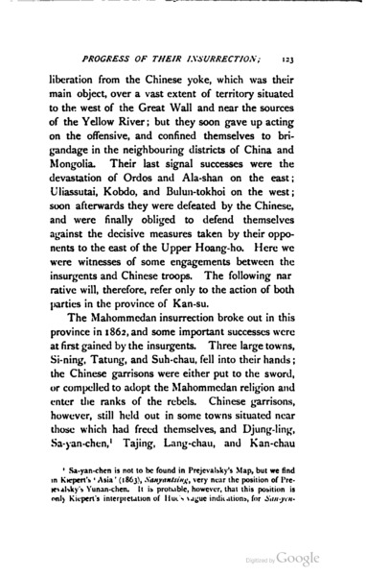

### identifier

16e0db1f-5eee-435b-9ad4-52dde6894366

### creator

Przhewalskii, Nikolai

### type

Text

### coverage

China

Gansu

Mongolia

Tibet

### description

Ethnographic observations are summarized in chapter II, which provides detail on the following topics: “The Mongols — Physical characteristics — Modification of character on the Chinese border — Pigtail introduced — Costimie — The Yurta or Felt Tent — Uncleanliness — Tea-drinking— Food and beverages — Gluttony— Animal food — Cattle— Importance of their herds — Indolent habits — Physical capabilities and defects — Cowardice— Sagacity and obtuseness — Curiosity — Points of the compass — Estimation of distance — Calendar and Year-Cycle— Language and diversities— Literature — Love of gossip — Songs — Mongol women — Marriage customs and domestic relations — Hospitality and polite customs — Freedom of manners — Lamaism — Religious service — 'Om mani padmi hom' — The Dalai Lama — Pilgrimages — The Clergy — Monasticism — Superstitions — Masses for the dead — The Author's view of Missions — Administrative organisation of the Mongol tribes — Grades of rank among chiefs, and their salaries — Population — Laws, punishment, and taxation — Military force — Decay of martial spirit”.

Two-volume report of Colonel Przhewalskii’s expedition in Inner Asia, sponsored by the Geographical Society of Russia. The expedition took place between November 1870 and October 1873, taking Przhewalskii and his colleagues through Mongolia, Inner Mongolia, Gansu, and Tibet. The expedition primarily collected data on the physical geography, birds and mammals, and botany of the region; Przhewalskii returned to Russia with “1,000 specimens of birds belonging to 238 different genera; 130 skins of mammalia, large and small, comprising 42 kinds; about 70 specimens of reptiles; 11 descriptions of fish; and more than 3,000 specimens of insects”, along with “500 to 600 kinds of plants represented by 4,000 specimens”.

### publisher

Sampson Low, Marston, Searle, & Rivington

### source

<https://archive.org/details/mongoliatangutc00przhgoog>

### rights

Public domain

### subject

expeditions

geography

### date

1876

### language

English

### original filename

mongoliatangutc00przhgoog.pdf

### extent

9.4 MiB

### contributor

Morgan, F Delmar

### format

application/pdf

### modified

2017-10-09 12:53:49

### remote embed url

https://archive.org/embed/mongoliatangutc00przhgoog