Factnews.mn - Бидний амтархан уудаг “ГОЁ” таргыг Хятадад үйлдвэрлэдэг үү?

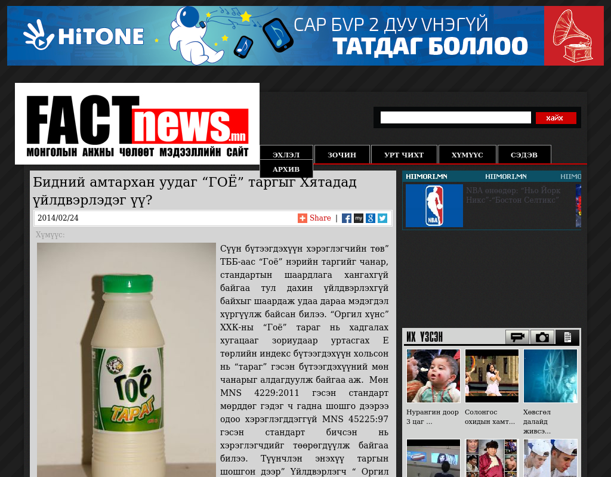

### identifier

1838bba6-f9ac-464a-924f-86b9f543077e

### creator

### type

Text

### coverage

Mongolia

### description

### publisher

### source

http://factnews.mn/eeo

### rights

### subject

Mongolia

dairy

nationalism

social media

### date

24 Mar 2014 13:38:11

### language

Mongolian

### format

text/plain

### modified

2018-01-11 14:12:43

### original filename

factnews.mn.Bidnii_amtarkhan_uudag.url

### extent

22.0 B