Photograph of Handgate, Xinjiang by Tsui Yen Hu, 1993, No. 35

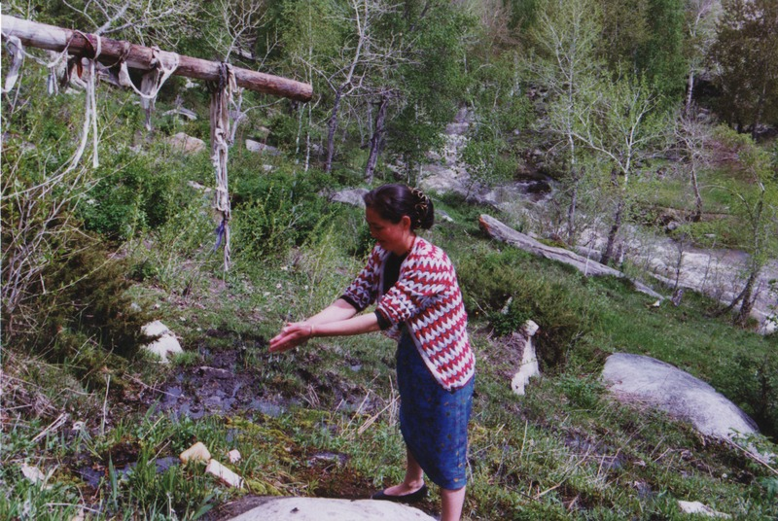

### identifier

19a6cbbf-4bd9-43a9-b113-806ef4a19c99

### creator

Tsui Yen Hu

### type

Image

### coverage

Altai district

Handgate

PRC

Xinjiang

### description

A young Kazakh woman at Five-Finger Spring

### publisher

### source

Scanned from colour print held in the archives of the University of Cambridge MacArthur Project "Environmental and Cultural Conservation in Inner Asia", Mongolia and Inner Asia Studies Unit.

### rights

### subject

natural sacred sites

### date

1993-05-27

### language

### format

image/png

### contributor

### original filename

TsuiYenHu-Handgate-1993-35.png

### relation

### extent

1777x1191 px

4.0 MiB