1798498. The Ritual of Calling Maitreya, Buddha of the Future

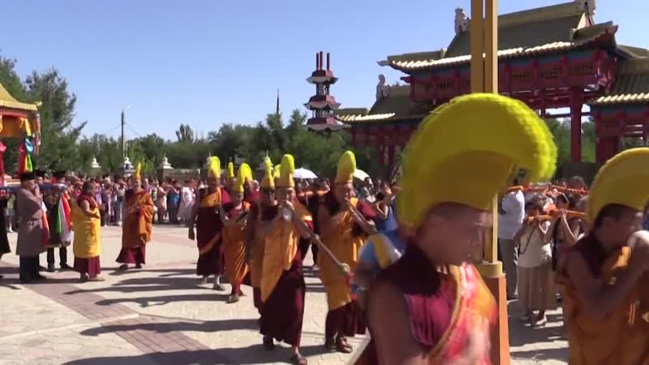

### identifier

1afc0432-4727-49cb-807a-f60d59d13111

### creator

Kalmyk Cultural Heritage Documentation Project

### type

Moving Image

### coverage

Kalmykia

Russia

### description

### publisher

University of Cambridge

### source

<http://www.kalmykheritage.socanth.cam.ac.uk>

### rights

Copyright Kalmyk Cultural Heritage Documentation Project. Licensed under a Creative Commons BY-NC-ND Unported license.

### subject

Buddhism

Kalmyks

### date

2015-04-24 07:01:43

### language

### extent

463.1 MiB

1259.520000

### format

video/mp4

### modified

2015-04-23 23:01:42

### original filename

1798526.mp4

### remote embed url

http://sms.cam.ac.uk/media/1798498/embed

### public

FALSE