2470789. Zurgan Lidzhieva, About Camels

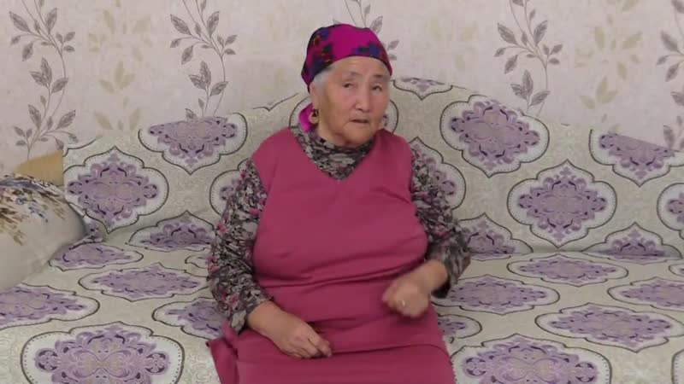

### identifier

1b22aaf0-5bc8-4182-ac41-6ce818acd011

### creator

### type

Moving Image

### coverage

Kalmykia

Russia

### description

### publisher

University of Cambridge

### source

<http://www.kalmykheritage.socanth.cam.ac.uk>

### rights

Copyright Kalmyk Cultural Heritage Documentation Project. Licensed under a Creative Commons BY-NC-ND Unported license.

### subject

Kalmyks

camels

livestock

### date

2017-05-01 08:29:41

### language

### format

video/mp4

### contributor

### original filename

2470798.mp4

### remote embed url

http://sms.cam.ac.uk/media/2470789/embed

### relation

### extent

131.2 MiB

359.120000

### public

FALSE