Map of contemporary mobility patterns in Dashbalbar

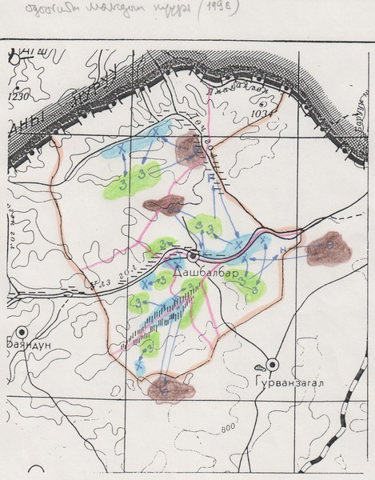

### identifier

1cf3ba50-8643-4be3-9b67-ce57243191c5

### creator

Batbuyan, B

### type

Image

### coverage

Mongolia

Dornod aimag

Dashbalbar sum

### description

This map depicts the contemporary mobility patterns described by research collaborators in Dashbalbar. The sum centre is depicted in the middle of the map; seasonal grazing areas are labelled as follows: summer (З) and autumn (Н) -- green, winter (Ө) -- brown, spring (Х) -- blue. Blue arrows depict the direction of movement.

### publisher

### source

Scanned from an original document held in the archives of the Mongolia and Inner Asia Studies Unit, University of Cambridge.

### rights

### subject

mobility patterns

maps

### date

1993

### language

Mongolian

### original filename

macarthur-dashbalbar-mobility-map_2.png

### relation

### extent

7.5 MiB

1814x2323 px

### contributor

### format

image/png

### modified

2017-05-25 10:38:48