Caroline Humphrey Mongolia Super8 film no. 7

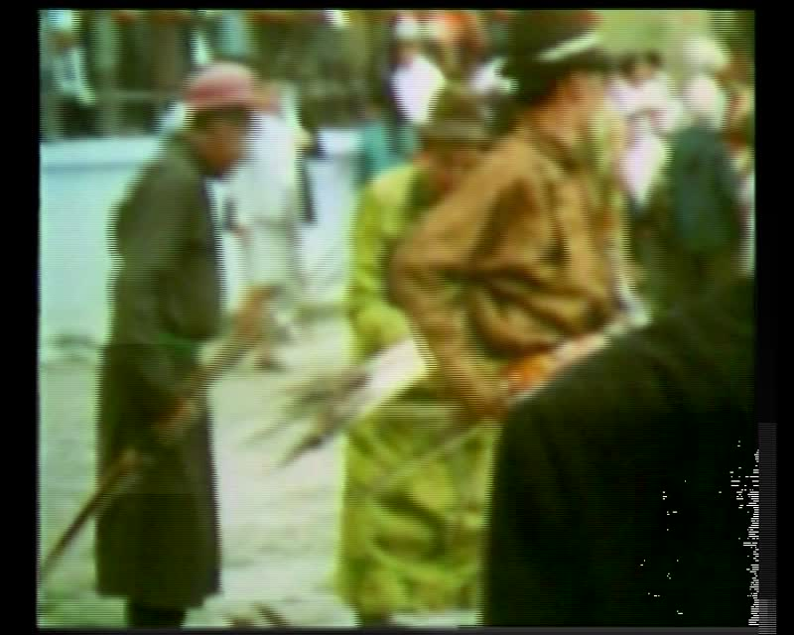

### identifier

1d309998-52c0-4e41-9560-555fd8a73e47

### creator

Humphrey, Caroline

### type

Moving Image

### coverage

Mongolia

Ulaanbaatar

### description

Horse-racing and archery in Ulaanbaatar.

### publisher

MIASU

### source

Digitized from a VCR transfer tape held at the Mongolia and Inner Asia Studies Unit, University of Cambridge

### rights

Copyright Caroline Humphrey

### subject

archery

horse-racing

naadam

### date

ca. 1970s

### language

None

### original filename

humphrey-super8-mongolia-07.mp4

### extent

1.2 GiB

309.760000

### format

video/mp4

### modified

2017-06-23 05:59:10

### alternate url

https://archive.org/embed/1d309998-52c0-4e41-9560-555fd8a73e47