Caroline Humphrey Mongolia Super8 film no. 1

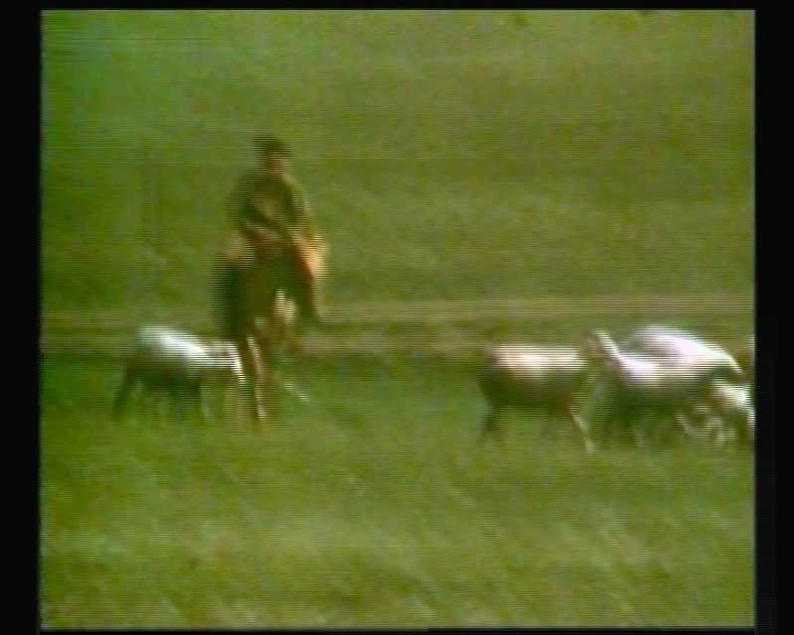

### identifier

1feebc78-628c-4acd-b1a9-76348db9cbcd

### creator

Humphrey, Caroline

### type

Moving Image

### coverage

Mongolia

### description

Wide shot of goats; sheep herding

### publisher

MIASU

### source

Digitized from a VCR transfer tape held at the Mongolia and Inner Asia Studies Unit, University of Cambridge

### rights

Copyright Caroline Humphrey

### subject

herding

livestock

### date

ca. 1970s

### language

None

### original filename

humphrey-super8-mongolia-01.mp4

### extent

878.3 MiB

211.392000

### format

video/mp4

### modified

2017-06-16 09:28:24

### alternate url

https://archive.org/embed/1feebc78-628c-4acd-b1a9-76348db9cbcd