Gerlee making strawberry jam

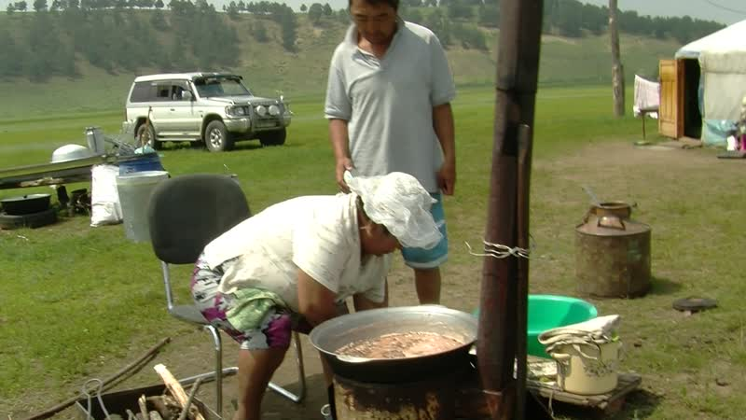

### identifier

20fd6f25-6af5-4dc3-adb7-22a80c2d3a21

### creator

Thrift, Eric

### type

Moving Image

### coverage

Mongolia

Selenge aimag

Yeröö sum

### description

The recordings in this series were taken in Tasag, Yeröö sum, Selenge aimag on the day following a strawberry-picking expedition. Gerlee makes strawberry jam in a 20-litre pot on her outdoor stove, then sets up her still to make milk liquor, and sterilizes jars in an electric pot, before finally pouring the jam into eight jars.

### publisher

### source

### rights

### subject

Pastoralism Videos

Making Strawberry Jam

Gerlee

### date

2012-07-14

### language

### format

inode/directory

### modified

2018-03-02 09:37:44

### original filename

PastoralismVideos--2012-07-14--MakingStrawberryJam--Gerlee--Selenge-Yeroo.vclips

### table of contents

|  |  |  |
| --- | --- | --- |
| time | clip | description |
| 0:00:00 | 300G0029 01 | Gerlee makes strawberry jam on the stove outside her yurt. She pours the strawberries from a plastic tub into the heated 20-litre pot on the stove, then adds sugar and begins stirring. |
| 0:13:53 | 300G0029 02 | Gerlee continues making strawberry jam. She gets two pieces of dung and adds them to the fire, continues stirring the berries a bit, then adds some wood to the stove. Gerlee goes into the yurt and comes back out with a small pot. She adds more wood to the fire, stirs the berries, and waits for the jam to boil. As foam begins to collect on the surface of the cooking jam, Gerlee ladles it off and puts it in the small pot. |
| 0:27:47 | 300G0029 03 | Gerlee continues cooking the strawberry jam. |
| 0:41:40 | 300G0029 04 | Dolgorsüren's son shows up in his car, asking for something, and Gerlee goes into her yurt to get it for him, then comes back to the stove. Her son Nyamdorj comes outside, talks for a few moments, then goes back indoors and brings a bowl. Gerlee continues ladling off the froth. |
| 0:55:10 | 300G0029 05 | Gerlee continues cooking the strawberry jam. She judges it is ready, and brings over the dung container and places the pot on top of it. She then gives a bowl of jam to taste. |
| 1:02:03 | 300G0030 01 | Gerlee has assembled her still on top of the stove where she was making jam; she scoops off some water from the upper basin and pours it into a tub. She adds water from a metal canister, and pours in some liquid soap, washes her hands, and begins cleaning the jars she will use for the jam. The curds remaining from the previous distillation of liquor continue to drain. |
| 1:15:57 | 300G0030 02 | Gerlee continues washing jam jars. After a few minutes she gets up and checks on the still, and adds some wood to the stove. She goes indoors and places several washed jars with their lids in her electric pot, then goes back out and brings the rest of the jars. |
| 1:23:25 | 300G0031 01 | Gerlee removes the sterilized jars and lids from the electric pot, then carries them outside in a pail. She scoops the jam into the jars, filling eight jars. |