Oral history interview No. 090744B with Osor (b. 1955): translation

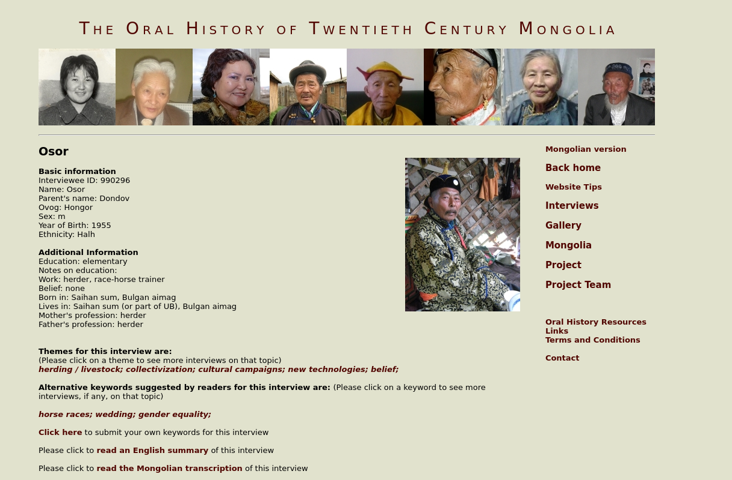

### identifier

21786dd4-aee6-4e8e-b53b-bbe42bb0fad5

### creator

Osor

### type

Text

### coverage

Bulgan aimag

Mongolia

### description

In the second part of his interview, Osor talked extensively about horses. He never imagined himself learning and becoming educated. He always thought of busying himself with horses. He was fond of horses, so starting with his youth and until these days he has lived this life thinking only about horses and race horses. Horses are blessed animals. There’s no Mongolian who doesn’t like a horse. Race horses occupy an important place in the lives of the Mongolians. He talked in detail about how to examine and identify the race horses, how to fix the tethering, how they are classified by their shapes and types. He also mentioned about riding race horses, about repression, the cultural campaigns, religion, lamas and the saints. He also talked about how the women’s position is changing in Mongolia, the men’s and women’s relations, the women’s social position and other relations concerning men and women.

### publisher

Oral History of Twentieth Century Mongolia

### source

<http://amantuuh.socanth.cam.ac.uk/search/view_trans.php?Interview=090744B>

### rights

Copyright MIASU. Reproduced with permission. Brief excerpts from interviews and other material may be used in academic or popular work for non-commercial purposes provided proper attribution and credit is given to the Oral History of Twentieth Century Mongolia and the Mongolia and Inner Asia Studies Unit (MIASU). You must not: (a) republish this material (including republication on another website) without the express written permission of MIASU; (b) sell, rent or sub-license material from the website; (c) show any material from the website in public without attribution to The Oral History of Twentieth Century Mongolia; (d) reproduce, duplicate, copy or otherwise exploit material on the website for a commercial purpose without express written permission; (e) use the material in any way that is damaging to the project or any of the persons named in the interviews. See <http://amantuuh.socanth.cam.ac.uk/terms.php> for details.

### subject

gender

horse races

oral history

wedding

### date

2009

### language

English

### format

text/plain

### contributor

Khishigsüren

### original filename

090744B-Osor-translation.url

### relation

dd6e48dc-67b2-4791-b3d4-4761bab0ce76

### extent

74.0 B