Owen Lattimore interviewed by Caroline Humphrey, 21st May 1983 – Part 2 (transcript)

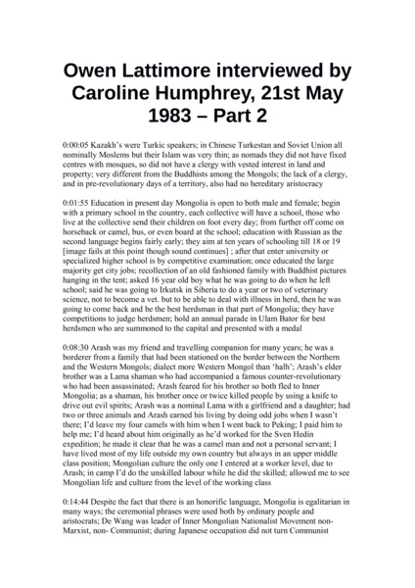

### identifier

21f37c7a-274c-4871-a77d-b1e9234205ba

### creator

Lattimore, Owen

### type

### coverage

Mongolia

China

### description

Owen Lattimore discusses Kazakhs; Mongolian education; his travelling companion Arash; Mongolian language and egalitarianism; Ulaankhuu and the Inner Mongolian nationalist movement; the Dilav Khutagt; the historian Dalai.

### publisher

### source

### rights

### subject

### date

1983

### language

English

### format

application/zip

### contributor

Humphrey, Caroline

### original filename

lattimore2.docx

### relation

### extent

8.9 KiB

### modified

2018-01-10 10:38:49

### remote embed url

### public