Хэвлэх

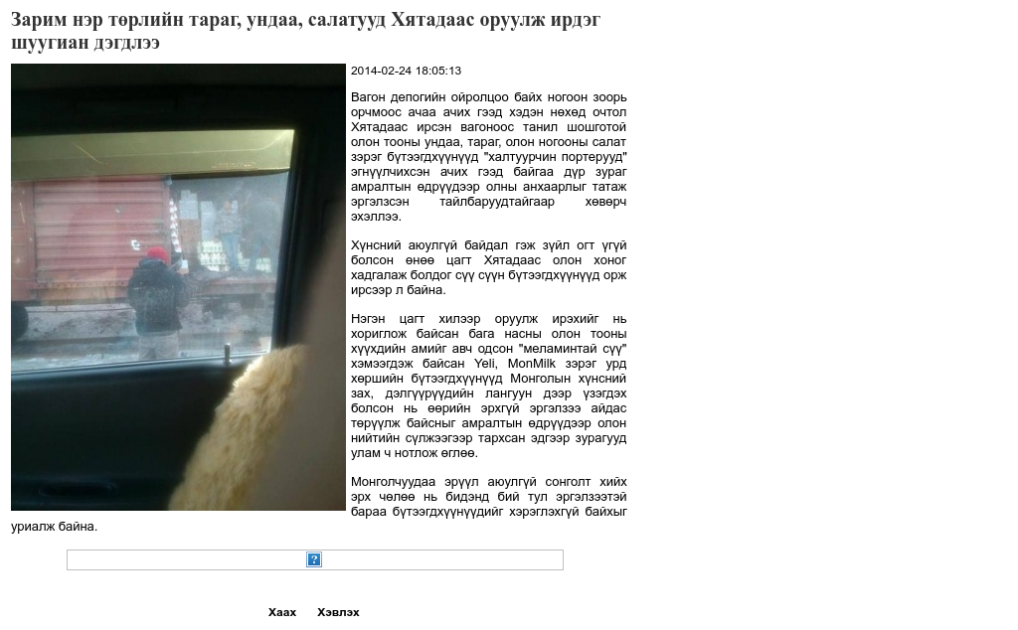

### identifier

225f8a3e-a761-491a-80aa-618d301d9a1b

### creator

### type

Text

### coverage

Mongolia

### description

### publisher

### source

http://uls.mn/pages/print.php?d=14031

### rights

### subject

Mongolia

dairy

nationalism

social media

### date

24 Mar 2014 14:26:30

### language

Mongolian

### format

text/plain

### modified

2018-01-11 14:12:43

### original filename

uls.mn.Zarim_ner_torliin_tarag.url

### extent

37.0 B