Photograph of Handgate, Xinjiang by Tsui Yen Hu, 1993, No. 42

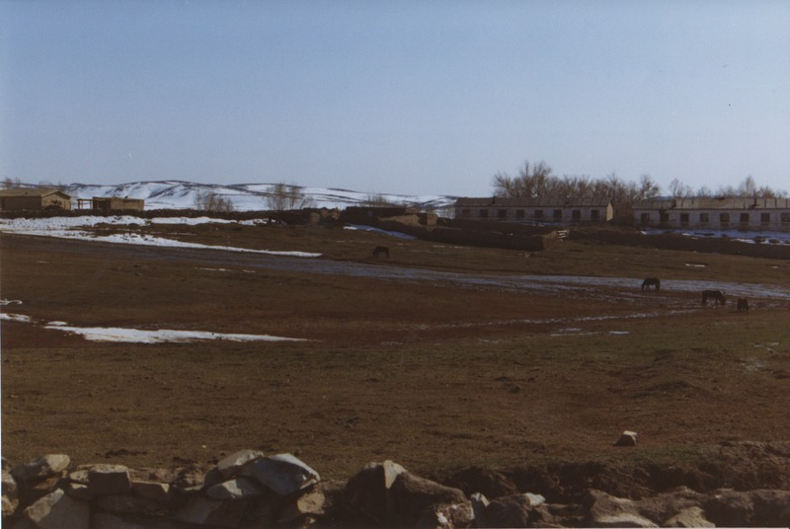

### identifier

22f273c0-0842-4b53-8ec4-181e3d45ed9a

### creator

Tsui Yen Hu

### type

Image

### coverage

Altai district

Handgate

PRC

Xinjiang

### description

Winter camp, Handgate, Altai

### publisher

### source

Scanned from colour print held in the archives of the University of Cambridge MacArthur Project "Environmental and Cultural Conservation in Inner Asia", Mongolia and Inner Asia Studies Unit.

### rights

### subject

pastoralism

### date

1993-03-14

### language

### format

image/png

### contributor

### original filename

TsuiYenHu-Handgate-1993-42.png

### relation

### extent

1777x1191 px

3.0 MiB