Caroline Humphrey - Buryatia photos - No. 3-02

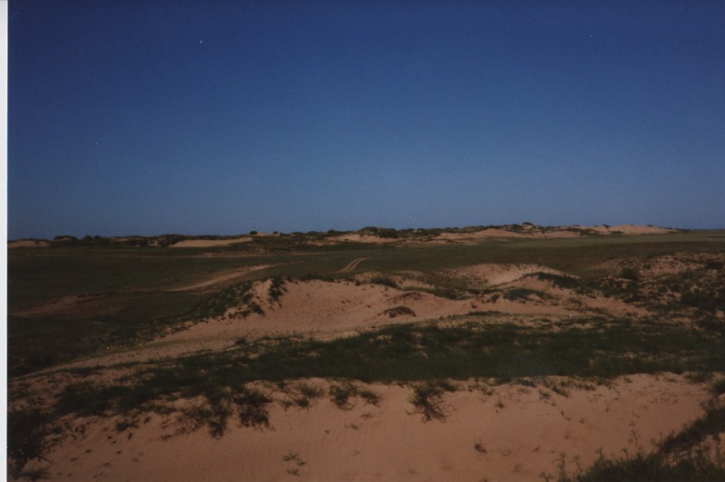

### identifier

254ca0e6-253a-430a-be4c-b6b5ad62d1b9

### creator

Humphrey, Caroline

### type

Image

### coverage

Khargant

### description

Sand dunes.

### publisher

### source

Scanned from a print held in the archives of the Mongolia and Inner Asia Studies Unit, University of Cambridge.

### rights

### subject

### date

1993

### language

### contributor

### original filename

Humphrey-Buryatia-photos-3-02.png

### relation

### extent

3.3MiB

1799x1196 px

### format

image/png