Caroline Humphrey - Buryatia photos - No. 09

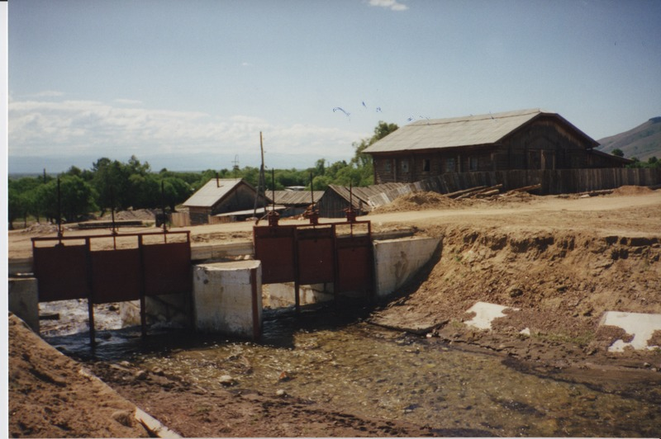

### identifier

2580a143-cfbf-4f87-a67b-e9d5b43d8429

### creator

Humphrey, Caroline

### type

Image

### coverage

Ulung Collective

Buryatia

USSR

### description

Open sluice gate for flour mill.

### publisher

### source

Scanned from a print held in the archives of the Mongolia and Inner Asia Studies Unit, University of Cambridge.

### rights

### subject

### date

1993-07-25

### language

### contributor

### original filename

Humphrey-Buryatia-photos-09.png

### relation

### extent

3.3MiB

1799x1196 px

### format

image/png