Harvesting wild strawberries in Yeröö

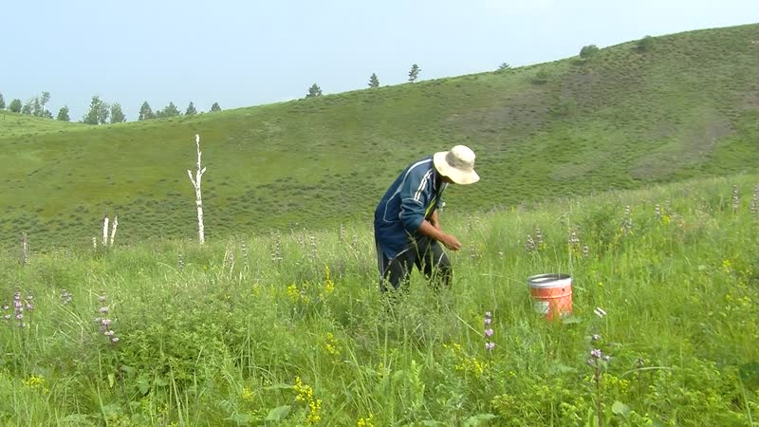

### identifier

26481f4f-0496-411d-ac41-9196eb4d0ca3

### creator

Thrift, Eric

### type

Moving Image

### coverage

Mongolia

Selenge aimag

Yeröö sum

### description

The recordings in this series depict wild strawberry harvesting by families from Yeröö sum, Selenge aimag. The families from Tasag pick strawberries at Bayangol, where the berries are found on the slopes of steep, wooded hills. This is an annual excursion; everyone goes picking just after Naadam (July 11-12), sometimes camping overnight in tents, but this year going just for the day. If the picking is good, and vehicles can be found, the most eager gatherers will go two or three times. Often relatives from the aimag centre and from Ulaanbaatar come to join in the strawberry picking. On the night of the picking (if camping out in the field) or the next day (if returning home at night), the berries are processed into jam. The most experienced gatherers manage to collect 20-30 litres in a day. On this occasion the group consists of me, my sister-in-law Naranjargal, Dolgorsüren, her son-in-law Mendee and his sister and daughter, her son Ganbat who lives in the aimag centre, her daughter and son-in-law Sarangerel and Altangerel from the sum centre, and Gerlee.

### publisher

### source

### rights

### subject

Pastoralism Videos

Harvesting Wild Strawberries

### date

2012-07-13

### language

### format

inode/directory

### modified

2018-03-02 09:37:44

### original filename

PastoralismVideos--2012-07-13--HarvestingWildStrawberries--Selenge-Yeroo.vclips

### table of contents

|  |  |  |
| --- | --- | --- |
| time | clip | description |
| 0:00:00 | 300G0025 01 | Picking strawberries. |
| 0:13:53 | 300G0025 02 | Picking strawberries. |
| 0:27:47 | 300G0025 03 | Picking strawberries. |
| 0:41:40 | 300G0025 04 | Picking strawberries. |
| 0:55:34 | 300G0025 05 | Picking strawberries. |
| 1:09:27 | 300G0025 06 | Picking strawberries. |
| 1:23:20 | 300G0025 07 | Picking strawberries. |
| 1:35:24 | 300G0026 01 | Picking strawberries. |
| 1:49:18 | 300G0026 02 | Picking strawberries. |
| 2:03:11 | 300G0026 03 | Picking strawberries. |
| 2:16:28 | 300G0027 01 | Picking strawberries. |
| 2:30:21 | 300G0027 02 | Picking strawberries. |
| 2:35:23 | 300G0028 01 | Picking strawberries. |