4024

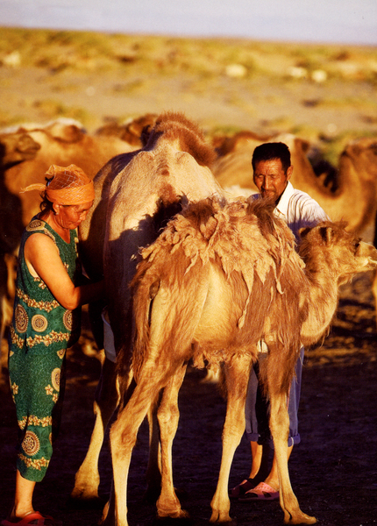

### identifier

2790f9c4-ce1b-4e2e-aa5b-2f2253ab1cb2

### creator

Oktyabri, D.

### type

Image

### coverage

Mongolia

### description

A woman milking a camel

### publisher

### source

https://ich.unesco.org/img/photo/src/4024.jpg

### rights

### subject

### date

2010

### language

### original filename

04024.jpg

### extent

2.7 MiB

1221x1703 px

### format

image/jpeg

### modified

2012-12-05 02:28:25