Photograph of Handgate, Xinjiang by Tsui Yen Hu, 1993, No. 16

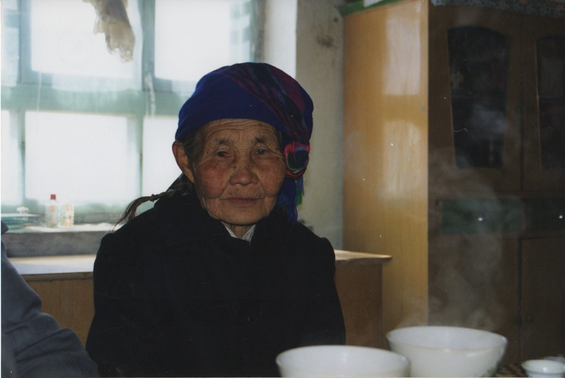

### identifier

2792eccf-eab8-4fc5-81d2-d23b2666aafb

### creator

Tsui Yen Hu

### type

Image

### coverage

Altai district

Handgate

PRC

Xinjiang

### description

An Uriyanghai woman, centre of Handgate

### publisher

### source

Scanned from colour print held in the archives of the University of Cambridge MacArthur Project "Environmental and Cultural Conservation in Inner Asia", Mongolia and Inner Asia Studies Unit.

### rights

### subject

Handgate centre

### date

1993-04-01

### language

### format

image/png

### contributor

### original filename

TsuiYenHu-Handgate-1993-16.png

### relation

### extent

1777x1191 px

3.0 MiB