Photographs from Barguzin, No. 14

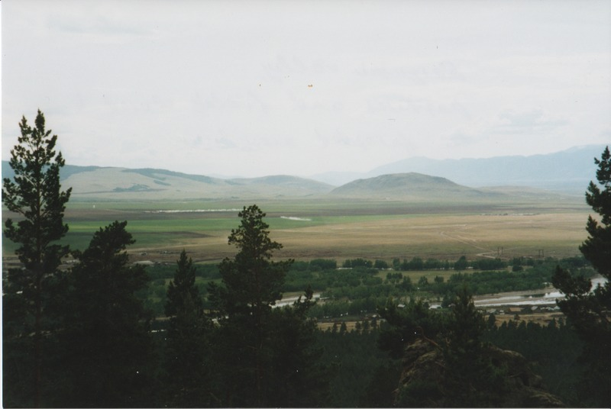

### identifier

27bce054-c0d8-40c1-bad9-b11039e97188

### creator

Gomboev, Bair

### type

Image

### coverage

Barguzin

Burtyatia

Russian Federation

### description

Barguzin Valley, pastures and fields near the forested mountains (“utug” hayfields near river).

### date

1993-07

### language

### format

image/png

### modified

2017-05-25 02:08:50

### original filename

bair-batbuyan-photos-14.png

### source

Scanned from a photographic print held in the archives of the Mongolia and Inner Asia Studies Unit, University of Cambridge

### extent

2.9 MiB

1777x1191 px

### subject

hay

rangeland