Idealist database input flowchart

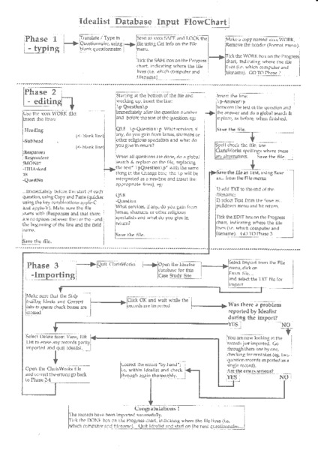

### identifier

2819b6b6-74f6-4f69-af1f-2b17b4934703

### creator

Chopping, Mark

### type

Text

### coverage

### description

Flowchart outlining the steps for preparing and inputting data from ethnographic interviews. The transcript or summary from each interview was first typed in a word processor (Claris Works), using designated codes to identify each question and response. This text was then imported into a database that allowed simple keyword and full-text searching of interview data, as well as filtering by location, question, and respondent type.

### publisher

### source

Scanned from an original document held in the archives of the Mongolia and Inner Asia Studies Unit, University of Cambridge.

### rights

### subject

data entry

### date

ca. 1992

### language

English

### original filename

macarthur-database-input-flowchart.pdf

### relation

### extent

200.7 KiB

### contributor

### format

application/pdf

### modified

2017-05-25 18:47:26