Photographs of Dashbalbar sum, No. 36

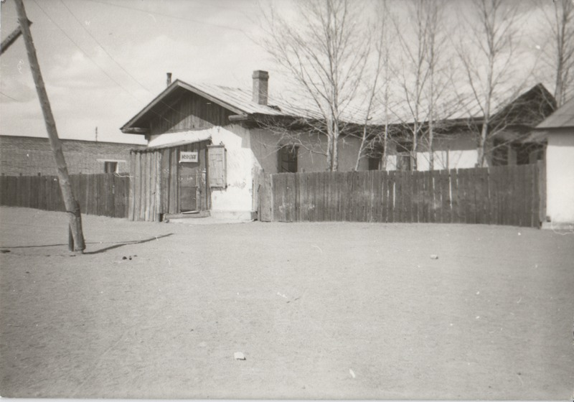

### identifier

29197ede-e7c9-4b03-a996-8ebbe77c4fa2

### creator

Batbuyan B.

### type

Image

### coverage

Dashbalbar sum

Dornod aimag

Mongolia

### description

Shopts of a *khorshoo* (cooperative) and company, Dashbalbar sum centre.

### publisher

### source

Scanned from a photographic print held in the archives of the Mongolia and Inner Asia Studies Unit, University of Cambridge.

### rights

### subject

commerce

settlements

### date

ca. 1993

### language

### format

image/png

### contributor

### original filename

bair-batbuyan-photos-36.png

### relation

### extent

1515x1061 px

2.3 MiB