Racing camels

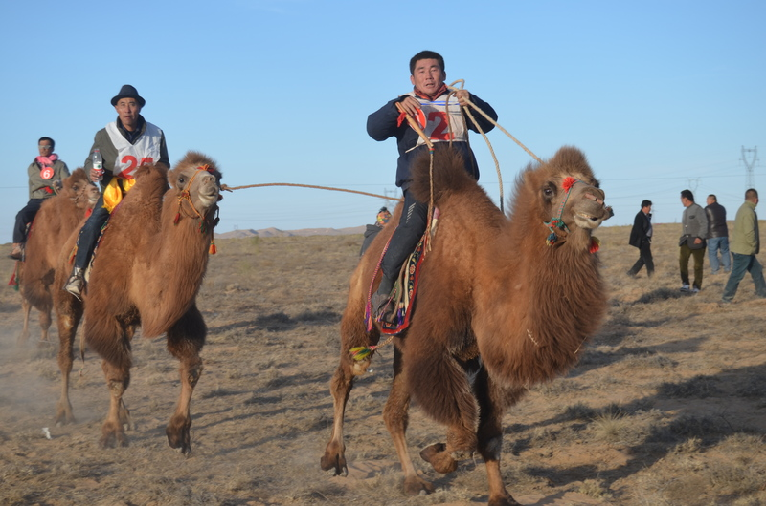

### identifier

2ad49eba-c136-46be-96fd-408a5408fce2

### creator

White, Thomas

### type

Image

### coverage

Alashan

Inner Mongolia

PRC

### description

Racing camels.

### publisher

### source

Image submitted by the author.

### rights

Copyright Thomas White. All rights reserved. Please contact the author for information on re-use.

### subject

camels

### date

2013-11-09 09:55:36

### language

### format

image/jpeg

### contributor

### original filename

DSC_0215.JPG

### relation

### extent

3.5MiB

4928x3264 px